**DDL**

CREATE DATABASE CSCI402;

USE CSCI402;

CREATE TABLE IF NOT EXISTS `Student` (

`StudentID` INT NOT NULL,

`StudentName` VARCHAR(50) NOT NULL,

`StudentType` VARCHAR(45) NULL,

`StudentEmail` VARCHAR(45) NULL,

PRIMARY KEY (`StudentID`),

UNIQUE INDEX `StudentID_UNIQUE` (`StudentID` ASC));

CREATE TABLE IF NOT EXISTS `CSCI402`.`Event` (

`EventID` INT NOT NULL,

`EventType` VARCHAR(45) NOT NULL,

PRIMARY KEY (`EventID`),

UNIQUE INDEX `EventID_UNIQUE` (`EventID` ASC));

CREATE TABLE IF NOT EXISTS `CSCI402`.`Schedule` (

`ScheduleID` INT NOT NULL,

`ScheduleName` VARCHAR(45) NULL,

`Date` DATETIME NULL,

‘Location’ VARCHAR(50),

PRIMARY KEY (`ScheduleID`));

CREATE TABLE IF NOT EXISTS `CSCI402`.`Employee` (

`EmployeeID` INT NOT NULL,

`EmployeeName` VARCHAR(45) NOT NULL,

`EmployeeEmail` VARCHAR(80) NOT NULL,

`EmployeeType` VARCHAR(45) NOT NULL,

PRIMARY KEY (`EmployeeID`));

CREATE TABLE IF NOT EXISTS `CSCI402`.`Faculty` (

`Salary` DOUBLE NULL,

`term` VARCHAR(200) NULL,

`Employee_EmployeeID` INT NOT NULL,

INDEX `fk_Faculty_Employee1_idx` (`Employee_EmployeeID` ASC),

CONSTRAINT `F_EmployeeID`

FOREIGN KEY (`Employee_EmployeeID`)

REFERENCES `CSCI402`.`Employee` (`EmployeeID`));

CREATE TABLE IF NOT EXISTS `CSCI402`.`Company` (

`CompanyID` INT NOT NULL,

`CompanyName` VARCHAR(45) NULL,

`CompanyContact` TEXT(200) NULL,

PRIMARY KEY (`CompanyID`));

CREATE TABLE IF NOT EXISTS `CSCI402`.`Supply` (

`SupplyID` INT NOT NULL,

`SupplyName` VARCHAR(45) NULL,

`SupplyType` VARCHAR(45) NULL,

`CompanyID` INT NOT NULL,

PRIMARY KEY (`SupplyID`, `CompanyID`),

CONSTRAINT `fk_Supply_Company1`

FOREIGN KEY (`CompanyID`)

REFERENCES `CSCI402`.`Company` (`CompanyID`));

CREATE TABLE IF NOT EXISTS `CSCI402`.`Document` (

`DocumentID` INT NOT NULL,

`DocumentName` VARCHAR(45) NULL,

`DocumentDate` DATETIME NULL,

`DocumentType` VARCHAR(45) NOT NULL,

`Company_CompanyID` INT NOT NULL,

PRIMARY KEY (`DocumentID`, `Company_CompanyID`),

CONSTRAINT `fk_Document_Company1`

FOREIGN KEY (`Company_CompanyID`)

REFERENCES `CSCI402`.`Company` (`CompanyID`));

CREATE TABLE IF NOT EXISTS `CSCI402`.`BackstageMaterial` (

`B_SupplyID` INT NOT NULL,

`BackstageType` VARCHAR(45) NULL,

CONSTRAINT `fk_BackstageMaterial_Supply1`

FOREIGN KEY (`B_SupplyID`)

REFERENCES `CSCI402`.`Supply` (`SupplyID`));

CREATE TABLE IF NOT EXISTS `CSCI402`.`RehearsalMaterial` (

`R_SupplyID` INT NOT NULL,

`RehearsalMaterialType` VARCHAR(45) NULL,

CONSTRAINT `R_SupplyID`

FOREIGN KEY (`R_SupplyID`)

REFERENCES `CSCI402`.`Supply` (`SupplyID`));

CREATE TABLE IF NOT EXISTS `CSCI402`.`Guardian` (

`GuardianID` INT NOT NULL,

`GuardianName` VARCHAR(45) NULL,

`GuardianContact` VARCHAR(45) NULL,

`Student_StudentID` INT NOT NULL,

PRIMARY KEY (`GuardianID`, `Student_StudentID`),

CONSTRAINT `fk_Guardian_Student1`

FOREIGN KEY (`Student_StudentID`)

REFERENCES `CSCI402`.`Student` (`StudentID`));

CREATE TABLE IF NOT EXISTS `CSCI402`.`StudentStaff` (  
 `employement` VARCHAR(45) NOT NULL,  
 `Employee_EmployeeID` INT NOT NULL,  
 CONSTRAINT `S_EmployeeID`  
 FOREIGN KEY (`Employee_EmployeeID`)  
 REFERENCES `CSCI402`.`Employee` (`EmployeeID`));

CREATE TABLE IF NOT EXISTS `CSCI402`.`Involvement` (

`Event_EventID` INT NOT NULL,

`Student_StudentID` INT NOT NULL,

INDEX `fk_Event_has_Student_Student1_idx` (`Student_StudentID` ASC),

INDEX `fk_Event_has_Student_Event1_idx` (`Event_EventID` ASC),

CONSTRAINT `fk_Event`

FOREIGN KEY (`Event_EventID`)

REFERENCES `CSCI402`.`Event` (`EventID`)

ON DELETE NO ACTION

ON UPDATE NO ACTION,

CONSTRAINT `fk_Student`

FOREIGN KEY (`Student_StudentID`)

REFERENCES `CSCI402`.`Student` (`StudentID`)

ON DELETE NO ACTION

ON UPDATE NO ACTION);

CREATE TABLE IF NOT EXISTS `CSCI402`.`StudentSchedule` (

`Student_StudentID` INT NOT NULL,

`Schedule_ScheduleID` INT NOT NULL,

`date` DATETIME NULL,

`location` VARCHAR(45) NULL,

INDEX `fk_Student_has_Schedule_Schedule1_idx` (`Schedule_ScheduleID` ASC),

INDEX `fk_Student_has_Schedule_Student1_idx` (`Student_StudentID` ASC),

CONSTRAINT `fk_Student_has_Schedule_Student1`

FOREIGN KEY (`Student_StudentID`)

REFERENCES `CSCI402`.`Student` (`StudentID`)

ON DELETE NO ACTION

ON UPDATE NO ACTION,

CONSTRAINT `fk_Student_has_Schedule_Schedule1`

FOREIGN KEY (`Schedule_ScheduleID`)

REFERENCES `CSCI402`.`Schedule` (`ScheduleID`)

ON DELETE NO ACTION

ON UPDATE NO ACTION)

ENGINE = InnoDB

CREATE TABLE IF NOT EXISTS `CSCI402`.`EmployeeSchedule` (

`Schedule_ScheduleID` INT NOT NULL,

`Employee_EmployeeID` INT NOT NULL,

`date` DATETIME NULL,

`location` VARCHAR(45) NULL,

PRIMARY KEY (`Schedule_ScheduleID`, `Employee_EmployeeID`),

INDEX `fk_Schedule_has_Employee_Employee1_idx` (`Employee_EmployeeID` ASC),

INDEX `fk_Schedule_has_Employee_Schedule1_idx` (`Schedule_ScheduleID` ASC),

CONSTRAINT `fk_Schedule`

FOREIGN KEY (`Schedule_ScheduleID`)

REFERENCES `CSCI402`.`Schedule` (`ScheduleID`)

ON DELETE NO ACTION

ON UPDATE NO ACTION,

CONSTRAINT `fk_Employee`

FOREIGN KEY (`Employee_EmployeeID`)

REFERENCES `CSCI402`.`Employee` (`EmployeeID`)

ON DELETE NO ACTION

ON UPDATE NO ACTION)

ENGINE = InnoDB

**DML**

INSERT INTO Student VALUES (100,"John Doe","TP", "[JD@gmail.com](mailto:JD@gmail.com)");

INSERT INTO guardian VALUES (213, "Laura Smith", "123-123-1234", 100);

INSERT INTO company VALUES (243,"Youth Theatre Supply","123-123-1234");

INSERT into supply values (252, "Bench", "Backstage", 243);

INSERT INTO backstageMaterial VALUES (252,"Props");

INSERT INTO document (documentID, DocumentName, DocumentType, Company_CompanyID) VALUES (232, "I'll Know", "Music Sheet", 243);

UPDATE document SET DocumentDate='2018-01-01' WHERE DocumentID = 232;

INSERT INTO employee VALUES(131, "Mia Park", "mia.park@biola.edu", "Faculty");

INSERT INTO employee VALUES(132, "Paul Adams", "paul.adams@biola.edu", "Student Staff");

INSERT into studentstaff values ("Fall", 132);

INSERT INTO faculty VALUES(12345.67, "Fall", 131);

INSERT INTO schedule (scheduleID, ScheduleName) values (114, "Dance rehearsal");

update schedule set date='2018-09-09' WHERE ScheduleID = 114;

INSERT INTO schedule (scheduleID, ScheduleName) values (112, "Parent Meeting");

update schedule set date='2018-12-12' WHERE ScheduleID = 112;

INSERT into employeeSchedule values (112, 131);

INSERT into studentSchedule values (114,100);

INSERT into event values (425, "Guys and Dolls");

INSERT into involvement values(425,100);

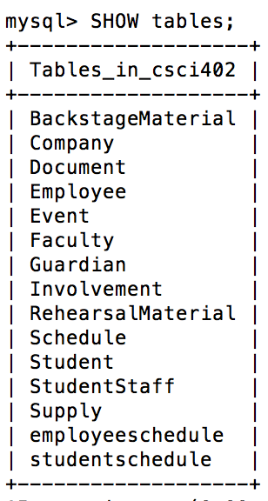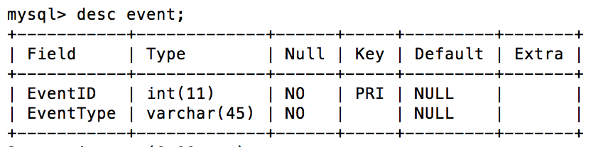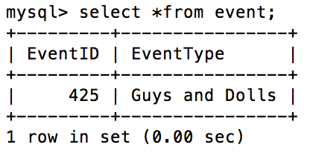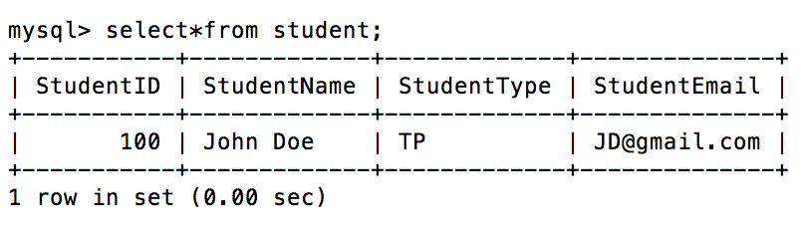

**Trying to find student involved in Guys and Dolls** →

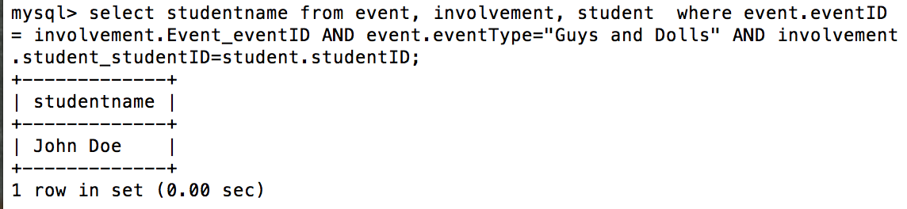

**Trying to find guardian contact for student named John Doe→**

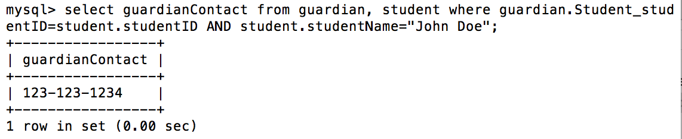

**Find the rehearsal date for Dance Rehearsal**

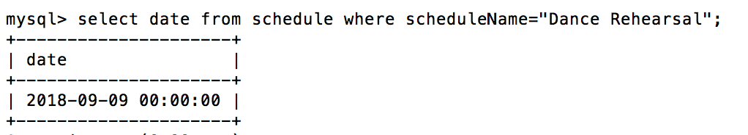

**List supplies that are props**

